Ideation Phase
Define the Problem Statements
Date | 31 January 2026
Team ID | LTVIP2026TMIDS34601
Project Name | TransLingua
Maximum Marks | 2 Marks

Customer Problem Statement:
Create a problem statement to understand your customer's point of view. The Customer Problem Statement template helps you focus on what matters to create experiences people will love.
A well-articulated customer problem statement allows you and your team to find the ideal solution for the challenges your customers face. Throughout the process, you’ll also be able to empathize with your customers, which helps you better understand how they perceive your product or service.
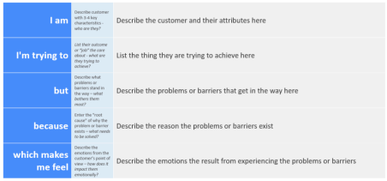Reference: https://miro.com/templates/customer-problem-statement/

Problem  Statement (PS) | I am  (Customer) | I’m trying to | But | Because | Which makes me feel
PS-1 | A business professional expanding to international markets | Translate business documents, marketing materials, and customer communications into multiple languages accurately | Hiring professional translators is expensive and time-consuming, and free tools often produce inaccurate or awkward translations | Traditional translation workflows create bottlenecks in our global expansion timeline and budget | Frustrated and limited in my ability to effectively communicate with a broader international audience
PS-2 | A university researcher collaborating with international peers | Translate research papers, academic articles, and team communications across different languages | Existing translation tools struggle with complex academic terminology and lose the nuanced meaning of scholarly texts | Academic language requires domain-specific understanding that general-purpose translators fail to provide | Overwhelmed by the manual effort required to ensure translation accuracy for critical academic work
PS-3 | A tourist visiting a foreign country | Understand local signs, menus, and communicate with locals in a language I don't speak | I can't carry a dictionary everywhere, and basic translation apps give robotic, context-less translations | Real-time communication needs demand instant, context-aware translations that feel natural | Anxious, isolated, and unable to fully experience the travel destination

